**Lab: Visible error-based SQL injection**

Problem:  The application uses a tracking cookie for analytics, and performs a SQL query containing the value of the submitted cookie. The results of the SQL query are not returned.The database contains a different table called users, with columns called username and password

Goal:  find a way to leak the password for the administrator user, then log in to their account.

Solve:

1-

2-

3-

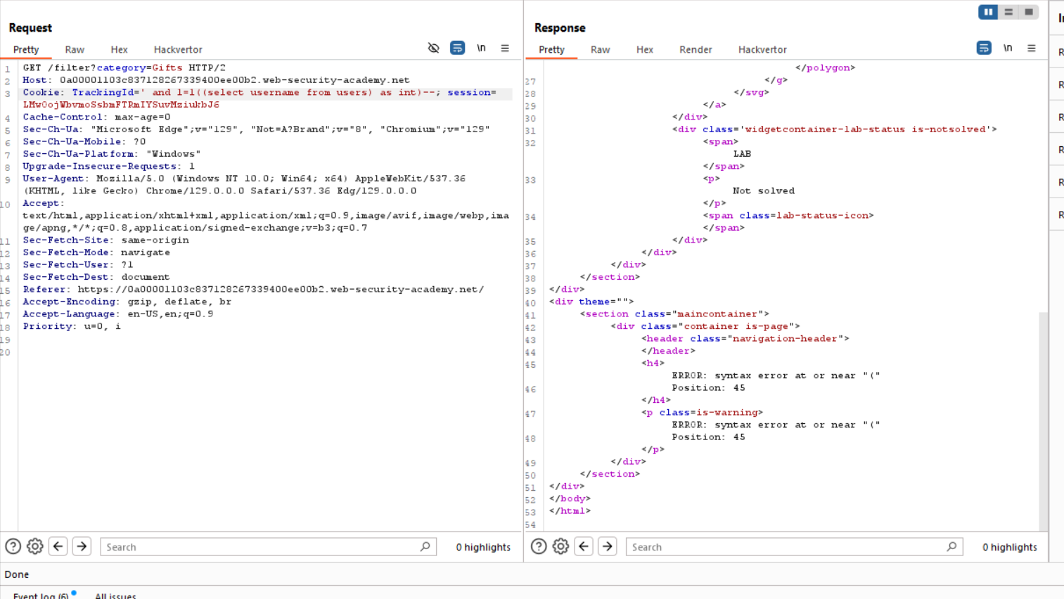

4-

5- password is 🡪 5nszpxnsyqx2gqmc9ck1

